***AURA METAL , WATCH ,FONT WATCH***

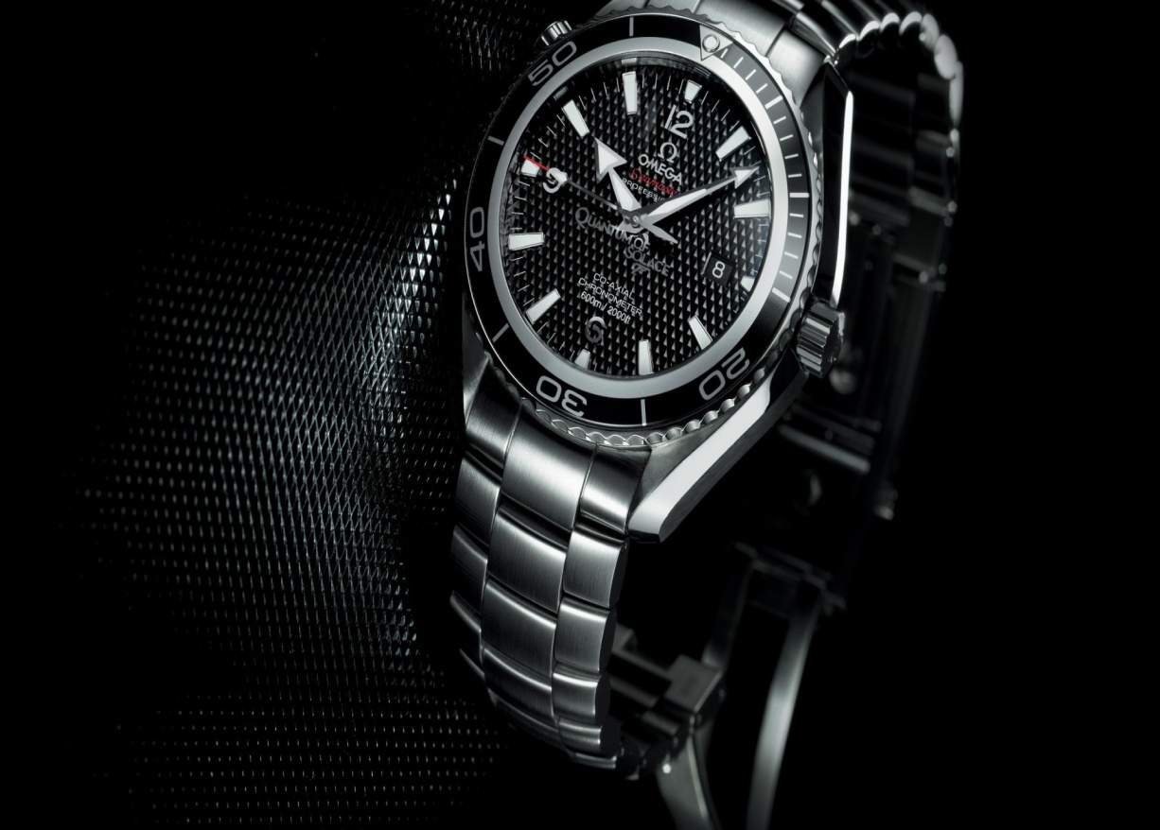

***Details This About Watch:***

Movement: Miyota Japanese quartz 6 hand chronograph with a 24hr subdial and date placement at 4 hour.  
Dial: The dial features faceted applied indices, printed seconds track, and custom molded hands.  
Case: 42mm, 100 meter/10 ATM custom solid stainless steel case, hardened mineral crystal, triple gasket crown with enamel fill, stainless steel screw down caseback and spring pin lugs.  
Band: 23-20mm tapered custom solid stainless steel 3 link bracelet with stainless steel double locking clasp with micro adjust

*Speces*

**CASE SHAPE:**Round

**CASE MATERIAL:**Stainless Steel

**MOV'T TYPE:**Quartz

**WATER RESISTANCE:**10 ATM

**STRAP MATERIAL:**Stainless Steel

**price:**

**rs:4,500**